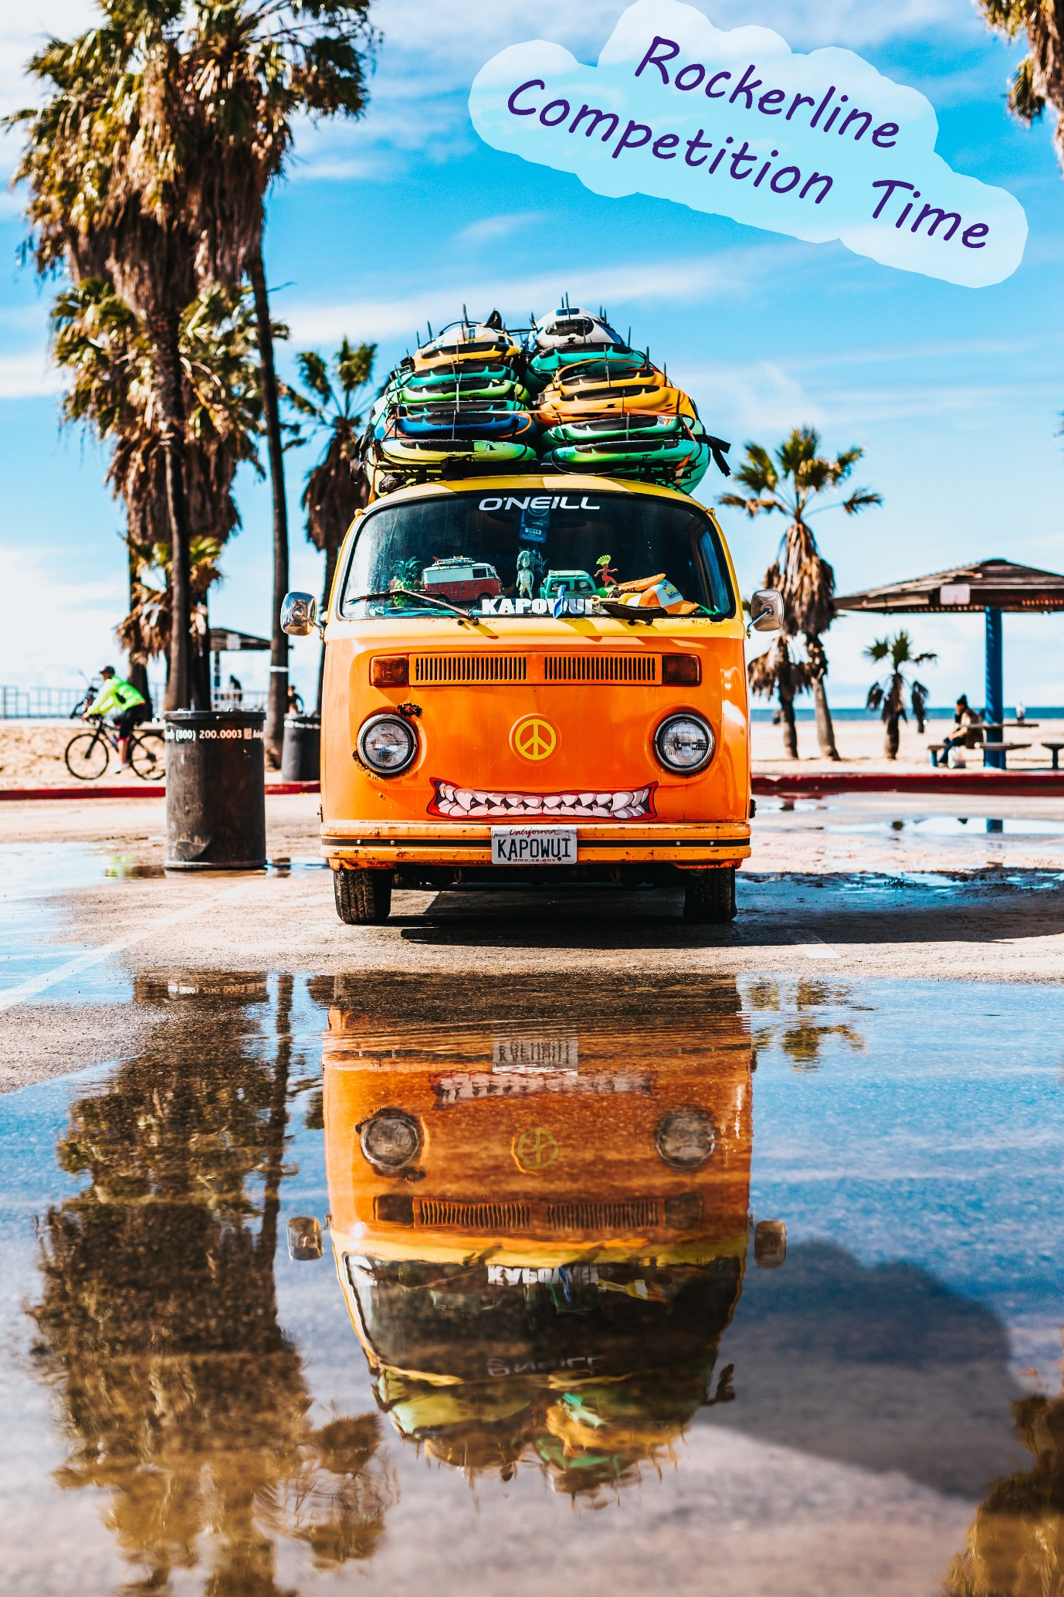

**Rockerline competition time**

Rockerline clothing would like to grant the opportunity for (set number) members of our community to win their very own Rockerline (item). To enter our competition, you must share this post, leave a comment and a photo of you exploring the great outdoors or doing your favourite outdoor sport related hobby with the hashtag (ideas “#KeepingFit” “#KeepingHealthy” “#OutdoorAdventure”).

The cut off point for this competition is (insert date), winners will be drawn at random and notified, Goodluck everyone!

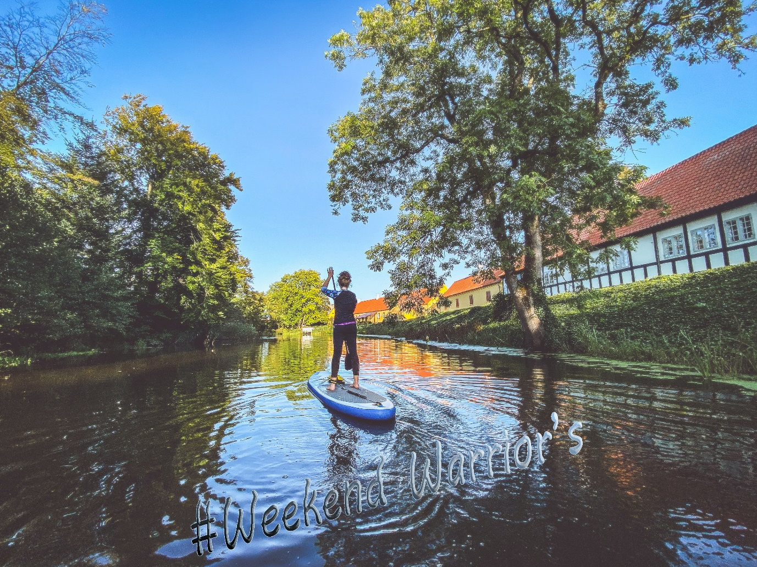

**Weekend warrior’s**

The Rockerline team are celebrating another successful weekend outdoors, we want to see what activity’s you do to relax and enjoy the great outdoors leave a comment bellow with a photo of you being sporty with the hashtag “#Weekend Warrior’s” to be featured next week and receive a 5% discount on your next order!

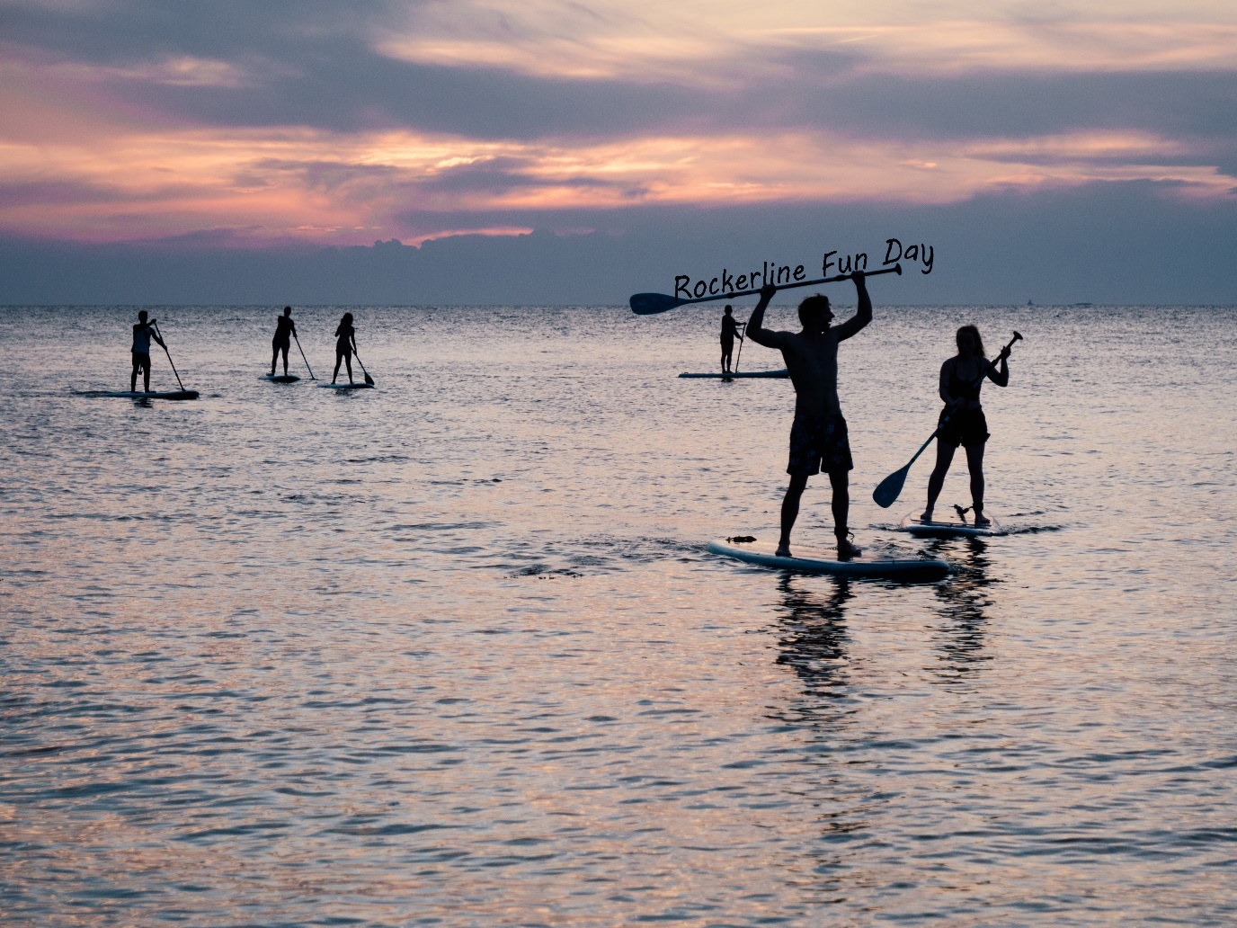

**Rockerline fun day**

Rockerline is partnering up with …. For a limited time, fun day at (location) giving the opportunity for new outdoor sport enthusiast try out beginner level activities such as (….) attending this fun day grants the opportunity to meet the team and receive a 10% discount on Rockerline clothing for the duration of the event. We hope to see you soon!

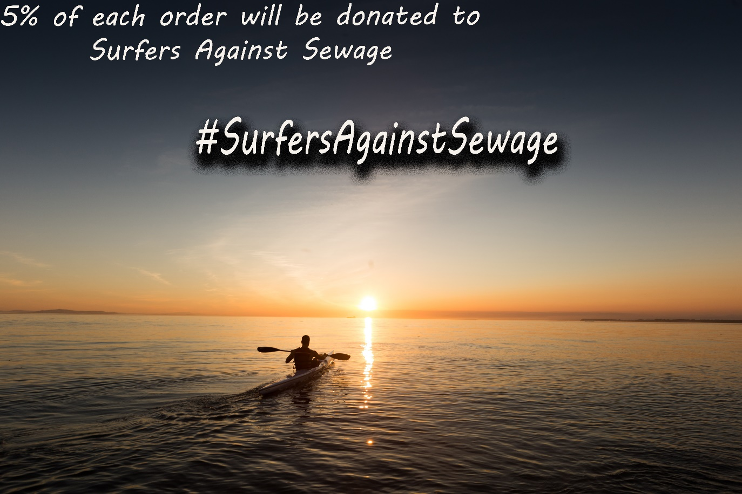

**

Rockerline support’s helping environment, so to give back to world Rockerline will be donating 5% of each water sport related item order to surfers against sewage! #SurfersAgainstSewage